100W Frameless BLDC Motor
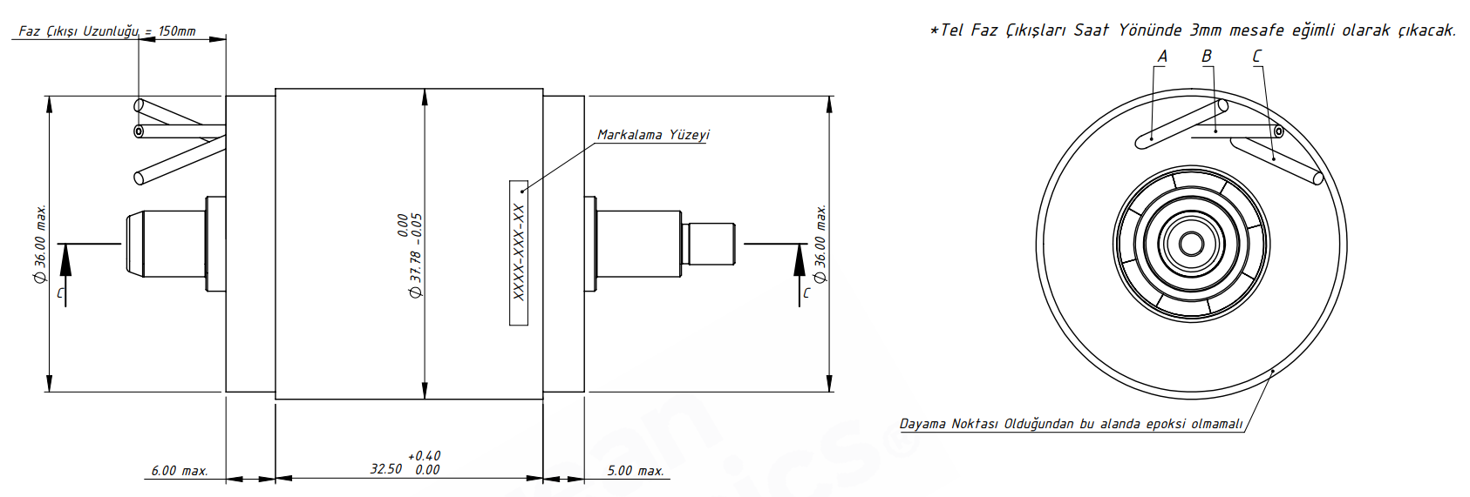
Basic Motor Parameters
Rated Power | W | 100
Rated Speed | rpm | 7000
Rated Torque | Nm | 0.14
Rated Current | A | 3.78
Rated Voltage | V | 28
No-Load Speed | rpm | 9853
Max. Efficiency | % | 90
Electrical Parameters
Number of Phases |  | 3
Number of Poles |  | 8
Torque Constant (KT) | Nm/A | 0.027
Back EMF Constant (KE) | Vs/rad | 0.029
Terminal Resistance Phase to Phase (±%10) | mΩ | 250
Terminal Inductance Phase to Phase (±%30) | mH | 130
Thermal Data
Ambient Temperature | °C | -40...+85
Max. Winding Temperature | °C | +155
Physical Parameters
Outer Diameter | mm | 32.78
Shaft Diameter | mm | 5
Max. Lenght | mm | 74
Weight | gr | 330
Motor Connection
U | Black (Left)
V | Black (Middle)
W | Black (Right)
Sensor Connection
N/A | N/A
Connector Articles
Power | N/A
Signal | N/A

